|  |
| --- |
| Cool Stuff To Do in Math: |
| A Qualitative Research Project on Using a Virtual Environment to Teach Personal Finance |
| 812 Final Project: Ellen Nosal |

After many hours of deliberation, research and transcriptions, I have learned much about myself, my research topic and qualitative research. My topic of interest focuses on interviews of high school students using a virtual environment to learn personal finance.

I chose this topic, as I have much experience to offer as a practitioner of the content and as one who has experienced the pitfalls and tribulations related to adult life. As a researcher, I want to know if there is any educational benefit to using a virtual environment to learn the material. My over all research goals are to create and investigate a pilot study of students using a virtual environment program in conjunction with taking a personal finance course. My specific goals for this course, was to interview high school students and understand their experiences in the use of a virtual environment for learning personal finance.

In completing my identity memo I have discovered how deep my passion for virtual environments is spilling over into my research identity. Through my research with virtual environments, I want to participate and give valid evidence on the benefits of these environments in schools, specifically high school settings.

The foundations of this identity begin to form in the fall of 2005. I had been given the worst teaching assignment of my career. This schedule included 2 preps, teaching two sections of algebra 1 part 1 and one class of personal finance. The Algebra 1 Part 1 students were level 3 students who could barely do basic math. Not one to waste lemons, I made the best pitcher of lemonade and shared it with all of my students. That year in Algebra, we used more technology in class and on assignments than any other math student in the school, and I enjoyed each of the student’s strong personalities and their gifts of honesty. As for the personal finance class, I was perplexed. No text was available or curriculum accessible and approved for the county, and past classes were special education self contained situations. Not finding any help, I asked my students what they wanted to learn about. During our first class we brainstormed ideas and concepts they wanted to know about. By the end the first hour of class, I and 7 other students created a curriculum for our class, we added a pacing guide, (when to teach concepts), and a syllabus to complete the picture. As the success of the class continued I had found a teaching niche. By student word of mouth, a worksheet, blow off class turned into a course you MUST take before graduation. In three years of teaching this course it went to 3 full sections of Personal Finance, and most importantly NO Algebra I Part I. I loved what I was doing. Helping future citizens understand how situations would play out in financial circles, and no one ever asked me:”when am I ever going to use this?”

In 2007 I continued my education at Mason with the Instructional Technology Program. In this program I began experiencing the new forums of virtual environments. I found using a virtual environment can aid learning. I discovered the River City Project for science and experimented with that with 9th grade students, but wanted to continue my focus of teaching personal finance.

I follow the careers of several educators who have pioneered the research with virtual environments and simulations in educational settings. With the creation and subsequent research that was the River City Project; my desire to use these programs and contribute to their success was ignited. The River City project was a 10 year study done through Harvard University lead by Dr. Chris Dede. I had the privilege in getting my students involved in the program, and in one simple ignorant comment by a substitute teacher, was inspired to research the use of virtual environments and simulations in the classroom.

In my search for virtual environments to use in school, I found Stagecoach Island. With our common goal to educate students about personal finance and finally a connection was made. A simulation was created which has experiences of home buying, construction, paying taxes and utilities, and keeping you in the black by having a job. I quickly made contact with the creators, demanded the IT personal at my school to make the program work, and engaged my students immediately. This program was so successful and a bonus to my curriculum, I began encouraging other educators to explore virtual environments. This led me to present my program at regional and international conferences. I met one of the creators of the virtual environment, insisted they come to a conference with me, where my students demonstrated the virtual environment to other excited educators.

In looking back at the recent financial problems, I believe more than ever students need to walk out high school and into to college life with a strong understanding of personal finance. In the beginning, I had a goal to expose students to basic concepts, but that has grown, basic is not enough. Students need experiences to really understand personal finance. They need to follow and track their money to understand their spending habits. I believe any education involving personal finance is beneficial. In my teaching I have had many parents comment: “I wish I had something like this when I was in school.” My experiences from teaching and my own learning of personal finance has made me a better teacher and better equipped to make sound financial decisions. As a teacher, I wanted my students to be prepared in learning about personal finance, and as a researcher I want to know if having experiences with a virtual environment is beneficial.

Through my research, I hope to give a positive voice to the validity of using simulations and virtual environments in teaching high school. The difficulty in this task is getting others to understand, “Why do they get to play games in this room?” This bias has becomes the greatest obstacle when trying to explain the operations of a virtual program or simulation. The quick demoting of an interactive thought provoking classroom activity to simple underrated video game play takes the wind out of any sail. Through this process my research questions have evolved to:

* Do these high school students find educational value using virtual environments?
* Do the experiences of a virtual environment lesson the fears one might have about their finances?
* What connections, if any, do these students make to real life personal finance situations?
* Are students who used a virtual environment more successful with their personal finance?

The use of virtual environments is already expanding at the elementary grade levels. Worlds such as Quest Atlantis, River City and Secret Builders, are being used daily in classrooms across the continents. Colleges are using Second Life, and the Reaction Grid to host virtual classes at their in-world Universities. The students are expected to collaborate and communicate in world and related their experiences verbally in face to face sessions and through discussions on message boards. In my research many studies have been done on the benefits of using virtual environments in elementary and college educational settings, specifically cooperative learning, reasoning and retention of material. In focusing on high school age students there is little research with regard to VE and their learning.

I firmly believe that given the technological advanced attitudes of teen agers and their innate ability to use technology, using a VE will, as previous studies have shown, advance their learning. I expect to see similar instances in cooperative learning, reasoning skills and retention of material as was demonstrated in other studies. I am influenced by the results of these studies but hope to find a distinction between the age groups. I believe high school aged students will be a more difficult audience and I am interested in their perceptions.

I believe a benefit of this study will encourage states to require personal finance courses for graduation. Presently, only a handful of states require any form of financial education for graduation. Because of the house and credit crash many states have scrambled to throw curriculum together for some form of financial education. I hope to provide evidence that virtual environments will be useful in understanding and retention of financial concepts.

Another research interest for me is the availability of virtual environments for high school users. Through early research I discovered only one such environment geared toward high school students, but dozens of simulations, many targeting the topic of personal finance. From recent financial troubles in the US and the world markets, these simulations and activities have grown in usage exponentially. Stagecoach Island is the virtual environment which supports learning personal finance and my goal in expanding the research in virtual environments. It is my research goal to run a pilot study using Stagecoach Island as the anchor in a personal finance curriculum to enhance the education of high school students.

With the increase of computer use in the classroom, many instructors look to enhance their courses with simulations and activities which help students learn and recall concepts. As schools compete with the requirements of a high-tech online world, games and simulations, both the use and creation of, will be important factors in a student’s high school career. It is my role as a researcher to gain legitimacy to the use of these excellent tools for education.

In transitioning to the actual project for this class I had to carefully look at my setting. As this was “my backyard” I wanted to ensure a smooth transition from practitioner to researcher. I chose this setting out of convenience as an employee of the school and I had a pool of participants with easy access to each of them. I identified my gate keepers and approached them in an appropriate chain of command. My administration granted their approval and I sent permission forms to prospective students. I was able to interview 6 students for 30 minutes apiece. During the week of November 1st to the 10th, I recorded conversations via a tablet computer and transcribed the conversation into a word processor. I was very concerned initially as all of these students had not used the program or seen any material for over a year and was very interested on what the students remembered and what were their perceptions of learning. From my memos I have the following information:

* AM -an African-American male 15 years of age. He is at the top of my interview list because he has used both River City and Stage Coach Island, one only real issue is his presently a student of mine. Permission formed given and returned signed.
* DP – and AA Male, 18 OY, was very hesitant at first but was the student who attended conference with me in 2009 and I really wanted his input. Permission formed given and returned signed and no teacher/student relationship.
* RS – 17 YO AA Female, who I initially did not ask, but was informed of the study by others and came to me and asked to participate. Permission formed given and returned signed and no teacher/student relationship.
* LD – 18YO, W Female, whom is very shy, I asked and was very interested in helping me out. Permission formed given and returned signed and no teacher/student relationship.
* GC – 19YO W Male Declines initial verbal request to participate later rescinded and joined interview process. Permission formed given and returned signed and no teacher/student relationship.
* LB – 17 YO W Female. Accepts invitation gladly and permission formed given and returned signed and no teacher/student relationship.

Interviews were conducted at the school during the students 30 minute lunch break. These interviews involved questions which would allow students to describe their experiences in the virtual environment and how it related to personal finance. SEE APENDIX 1. I observed the students as they answered questions and made notes after the conversations. All the students showed much excitement about the program and were very comfortable with me asking the questions.

In reviewing the data for my study I have transcribed the interviews and used a spreadsheet to organize the data into useful information. The document has 6 rows and 7 columns for the responses to the questions I have reviewed this document and concede I saw nothing. I changed tactics and create a visual representation of my text and discovered 4 organizational categories to begin working with. Financial Concepts, Gaming, Real Life and Learning became stepping off points for my assessment.

With my transcripts I used printouts and used various colors of highlighters to identify particular words. I coded theses words and ordered them into the table’s feature in a document editing program. In review these I notes I identified two categories which my participants expressed feelings and excitement and noted games and real life as those areas and added Interest and Future as substantive categories. Here I began to see the wealth of information these students retained and were excited to share.

In employing strategies I found the visual expression of my data to be most profound. The categories of financial concepts and learning were jam packed with text, where the other two categories of game and real life had only a few selections in each. I was interested to see how much material these students had retained by using this program. The main coding ideas formed this diagram.

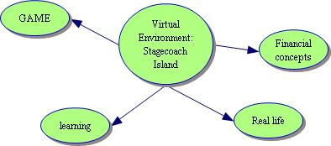

From the virtual environment extensions led to four main categories. These student identified areas of game, learning, real life, and financial concepts were what I was expecting to uncover in my research, but the surprising piece was the detail at which students focused on their learning related to financial concepts.

Financial Concepts

My transcripts were loaded with vocabulary and concepts dealing with financial learning. I was very excited and pleased to hear all of the items recalled by students. Thirty concepts appear from my six interviews and roughly all areas of banking and home-buying are accounted for. In further refinement a pattern of 3 more substantive categories emerge: banking, credit and responsibility become sub-groups of financial concepts. In these categories, students vocalized words and phrases with regard to the content of a personal finance course. I noted the strong correlation between the groups of financial concepts and real life as the subjects continually related each of the items to a real life setting.

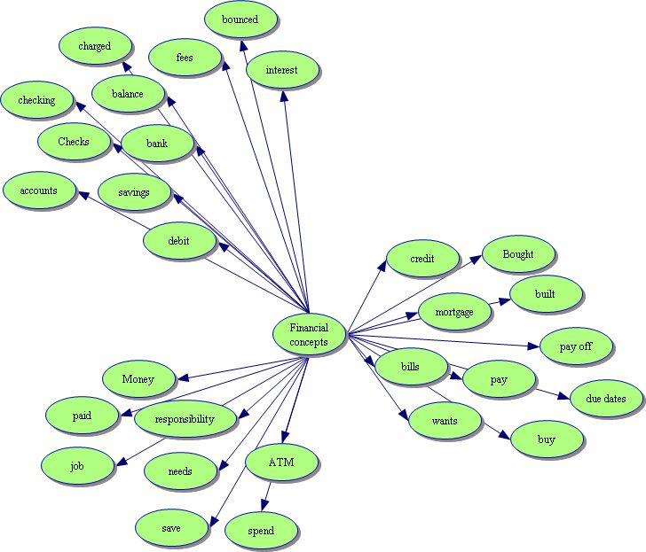

Game

In this area I looked for words or phrases which students attributed to game and the play aspect of the experience. These responses were focused on the enjoyment of the virtual environment and its ability to entertain. The student responses were less significant in the area of game play. Many students would have enjoyed the game less if it was not as focused on real life simulations and finance. The game novelty wore off quickly and instead took on a extended classroom feeling.

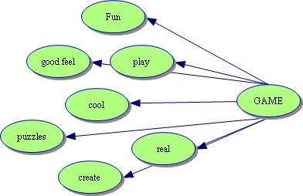

Real Life

In this area students used words and phrases which identify transfer to real life situations. Many words from the financial concepts also fell into this area, but the context at which the words were used placed them in the financial concepts category. Many words here also crossed over into the other categories of financial concepts and learning. Many phrases such as “learning this for our future” were coupled with “gotta login to get paid.” (Which was there translation to “got to work to get paid.”).

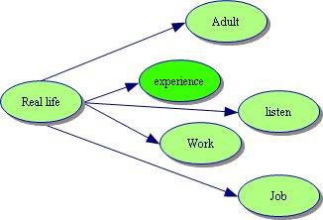

Learning

This was another are students had resounding responses too. Roughly twenty identifiable words or phrases appeared in the transcripts. These related to questions about how the students learned material. This diagram also showed a connection to the financial concepts and real life where students had a comparison another group.

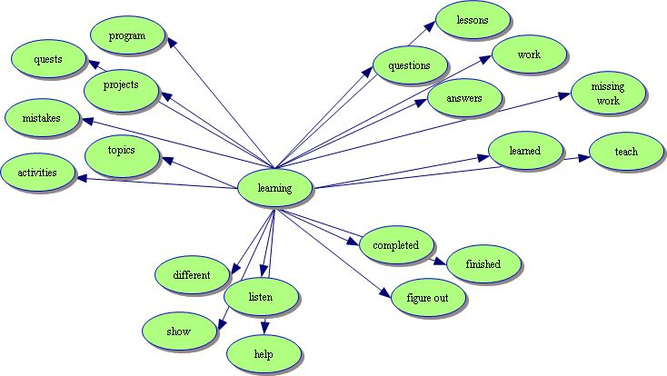

Interest

With regards to experiences with the virtual environment, the students used many of the same words to show their interest in the program and the activities they were involved. The following demonstrates the interest students have for a virtual environment.



Future

In the words and phrases students used I noted a relationship between the use of the program and its correlation to their specific futures. These words are denoted here and their relationship to these students upcoming endeavors.



These two cross over categories, become a corner stone for later research questions which I proposed. I believe these students did see a value in participating in this type of virtual environment. They clearly demonstrated the connections between the game and real world settings. Many students brought up relating a situation in the game to some incident in their world with regard to personal finance. GC states “I got charged for a bounced check…Learned my lesson and won’t be a Chuck again?” This is in reference to a character in the program who teaches them what to do in the learning modules.

In reviewing memos, notes, diagrams, and the matrix, I see the strongest inclination to student learning and financial concepts. In choosing my participants, I was extremely concerned my pool was not large enough to gather data. These students had used the program over a year ago and might have difficulty in articulating their intentions. My concerns were extinguished immediately with regard remembering concepts, but quite founded in their lack of vocabulary. The words cool and stuff appeared for every interviewee. I was also concerned my students would “give” me answers I was looking for and I found this to be unsubstantiated. These students expressed their honesty and appreciation for the program quite clearly. Through this, I believe these students found great value in the use of the virtual environment called Stagecoach Island.

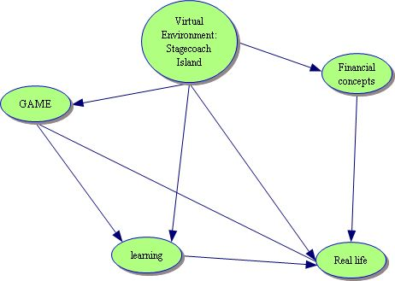

From this diagram, I find correlations that exist between games to learning, learning to real life and financial concepts to real life. These associations point to my other research questions of what connections, if any, do these students make to real life personal finance situations? And would these students, who used a virtual environment, be more successful with their personal finance? I would conclude that these research questions would be confirmed. Students so see value, they learned a great deal about personal finance and they would benefit in their future for knowing this material, therefore the program was beneficial to their learning.

As a practitioner of the personal finance, I am extremely biased in my belief this is content every student should be exposed to before graduation. As a researcher, I understand that bias can skew results. I believe I have been honest in my choosing my participants, my actions during the interview process and the resultant paper. I am supported by the numerous memos about my topic and I have learned a great deal about the mechanics of qualitative research. But I have learned more about myself and what drives me to succeed. Qualitative research is not easy; it is time consuming, thought provoking and complicated. But rich in results and understanding the human aspect of a research study. I am deeply committed to my topic and look to improve and refine my questions and research ideas further.

APENDIX 1

Interview Questions:

Tell me about your experience with using Stagecoach Island?

As this was a class project, what was a typical class like?

What draws you to use a virtual environment?

What did you like about the program?

What did you find difficult with the program?

How did you react to others in the program?

Did playing this game help you in school or real life financial situations?

If so what topic was it about?